Common CSS Issues:
- Incorrect Specificity: Styles not applying because more specific rules are overriding them.
- Missing or Incorrect Selectors: Using the wrong CSS selectors, preventing styles from being applied.
- Cascade and Inheritance Problems: Unintended styles due to the CSS cascade or inheritance.
- Box Model Issues: Problems with margin, padding, or border causing layout issues.
- Browser Compatibility: Styles not working as expected in different browsers.

Step-by-Step Guide: Debugging CSS Using Developer Tools
- Open Developer Tools:
  - Right-click on the webpage and select "Inspect" (or press F12).
  - This will open the Elements tab of the browser's developer tools.
- Inspect the Element:
  - Hover over the page elements in the "Elements" tab to see their visual highlight on the page.
  - Select the problematic element to view its HTML and associated CSS.
- Check Applied Styles:
  - In the Styles panel (usually on the right side), you will see all CSS rules applied to the selected element.
  - Strikethrough text indicates overridden or invalid CSS rules.
- Test Changes Live:
  - You can edit or add CSS directly in the Styles panel. Click on a property to change its value, or add new rules to see the effect immediately without changing the source code.
  - This allows for real-time debugging and testing.
- Check Specificity and Inheritance:
  - Scroll through the Computed tab to see the final values for all CSS properties, including inherited ones.
  - Use this to detect conflicts or missing properties that may not be applied.

Example of a CSS Issue and Debugging
Scenario:
A button on your page is supposed to have a red background, but it’s showing as gray.

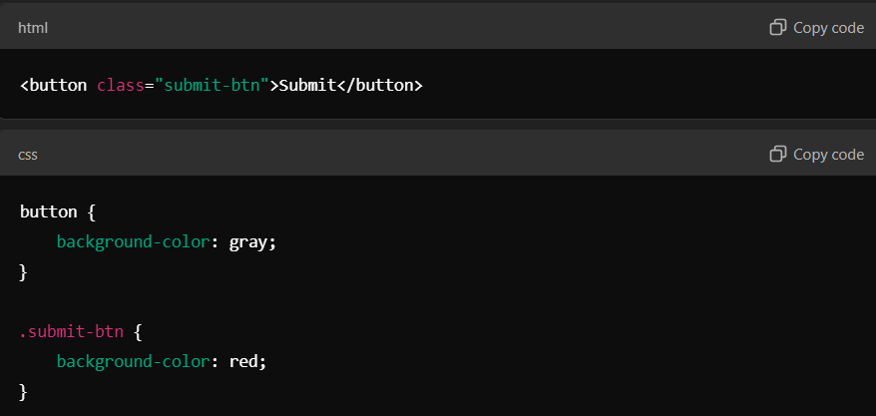
Steps to Debug:
- Inspect the Button:
Right-click the button, select "Inspect", and find the <button> element in the Elements tab.
- Check Applied Styles:
In the Styles panel, you'll see the button and .submit-btn styles. The background-color: gray; is applied because it has higher specificity (the element selector button overrides the class selector .submit-btn).
- Test Changes:
In the Styles panel, change the order of CSS rules or increase the specificity of the .submit-btn selector:
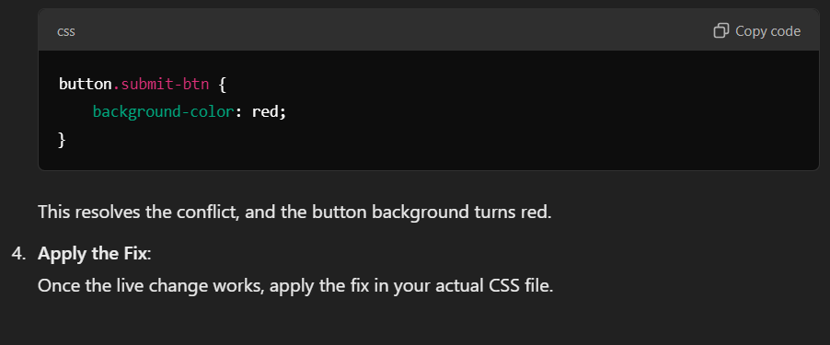

Key Debugging Tips:
- Console Errors: Check the console for errors that may affect CSS, such as broken links to external stylesheets.
- Toggle Styles: Disable or enable specific styles in the developer tools to see their impact on the element.
- Check for Overridden Rules: Look for any crossed-out CSS properties that are being overridden by more specific selectors.

